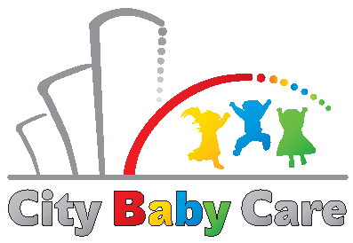
Zariadenie starostlivosti o deti do 3 rokov veku dieťaťa City Baby Care
Mlynské Nivy 12, Bratislava
twincity@citybabycare.sk

APPROVAL

With the processing of personal data for the purpose for promotial and informational purpose through photos and videos

Name and Surname of the child’s legal representative: ....................................................

Name and Surname of child: ...............................................................................................

Hereby
I AGREE – DISAGREE* with taking and publishing of photos and videos of my concerned child on the web pages, facebook or instagram profiles of Citybabycare, o.z.

I AGREE – DISAGREE* with the publication of childen’s name in the premises of the facility

I AGREE – DISAGREE* with the publication of childen’s name and photos by creating of promotional materials for Citybabycare, o.z.

I AGREE – DISAGREE* with the publication of childen’s name and photos for the needs of learning activities in children’s centers of Citybabycare, o.z. (classrooms, cloakroom, bedroom, washroom etc)

I am aware that this consent is not necessary for conclusion of service contract with Citybabycare, o.z.

I further declare, that I have been informed about the rights of the concerned person, and other important informations about the processing of personal data.

The childs legal representative may withdraw this consent any time in written form delivered to company’s registered office or via email.

In Bratislava, on .........................................

Signature of the child’s legal representative: ............................................................
*cross out inappropriate content

