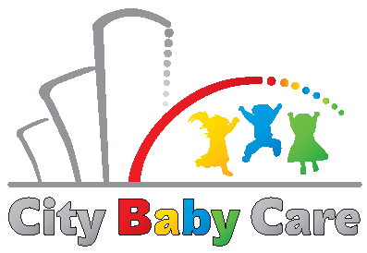
Zariadenie starostlivosti o deti do 3 rokov veku dieťaťa City Baby Care
Mlynské Nivy 12, Bratislava
twincity@citybabycare.sk

CONSENT
with the processing of personal data for the purposes of registration and reporting of the status of registered children

Name and Surname of legal representative: .......................................................

Name and surname of the child: .........................................................................
I hereby agree - disagree * Zariadenie starostlivosti o deti do 3 rokov veku dieťaťa City Baby Care, Mlynské Nivy 12, Bratislava (hereinafter referred to as "CBC") for processing operations with my personal data and my child's data, in particular obtaining, storing, providing to third parties: a company from the Swiss Re group in Slovakia (hereinafter referred to as "Swiss Re "), Implementačná agentúra Ministerstva práce, sociálnych vecí a rodiny SR (hereinafter also "IA MPSVR").
Scope of provided data - child's name and surname, parent's name and surname, child's age, date of entry into the facility, class placement.
The purpose of using personal data:
- for Swiss Re based on the CBC and Swiss Re cooperation agreement, a regular monthly update of the number of children from Swiss Re and outside Swiss Re visiting the CBC branch in the Twin City B,
- for IA MPSVR - during the implementation of the project Support for reconciliation of family and work life, call code: OP ĽZ DOP 2017/3.2.1/01.
Personal data is provided to third parties in an encrypted form, a file protected by a password, stored on a protected PC.
Provision of personal data from the information system Status of registered children to third parties not mentioned in the given list is permitted only with the additional written consent of the parent or legal representative.
I give this consent for the period necessary to achieve the purpose of the processing, max. for the duration of the contractual relationship, at the latest until the settlement of claims from the contractual relationship.
I further declare that I have been informed about the rights of the person concerned and other important information about the processing of personal data located on the website of the operator or on the notice board in the premises of the operation.
The legal representative can withdraw this consent at any time in writing to the address of the registered office of the company or by e-mail.

In Bratislava date........................ Signature of legal representative:......................................

* cross out those that do not apply
Zariadenie starostlivosti o deti do 3 rokov veku dieťaťa City Baby Care
Mlynské Nivy 12, Bratislava
twincity@citybabycare.sk
www.citybabycare.sk

